# SQL CODE:

U22561154

**Task 5:**

5.1) select F_name,M_name,L_name,sex,Ccontact_detail,Birth_date from client;

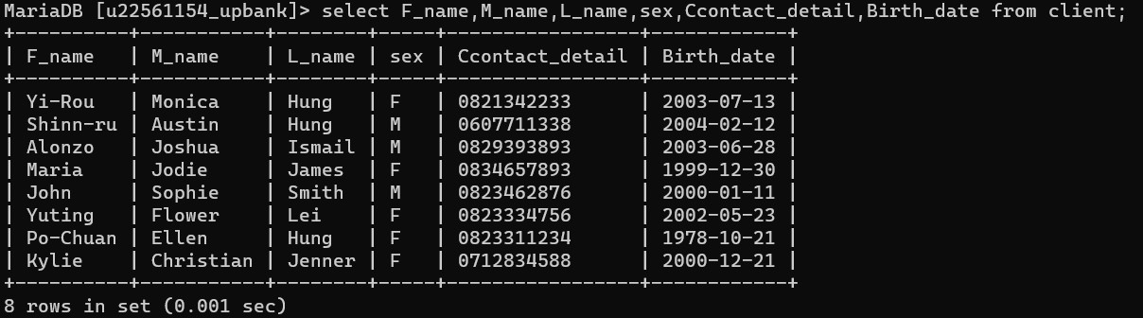

5.2) UPDATE branch SET Bnumber=0,Bstreet="" WHERE Bcity="Randburg";

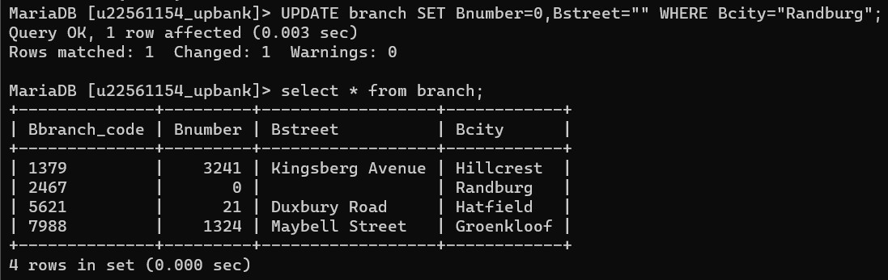

5.3) select * from client WHERE Address_proof=false;

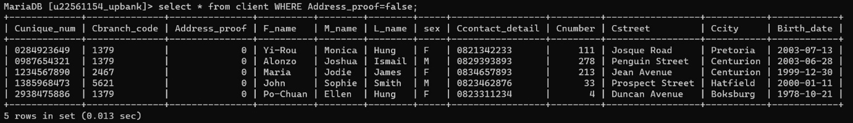

5.4) UPDATE atm SET Abranch_code="5621" WHERE Abranch_code="2467";

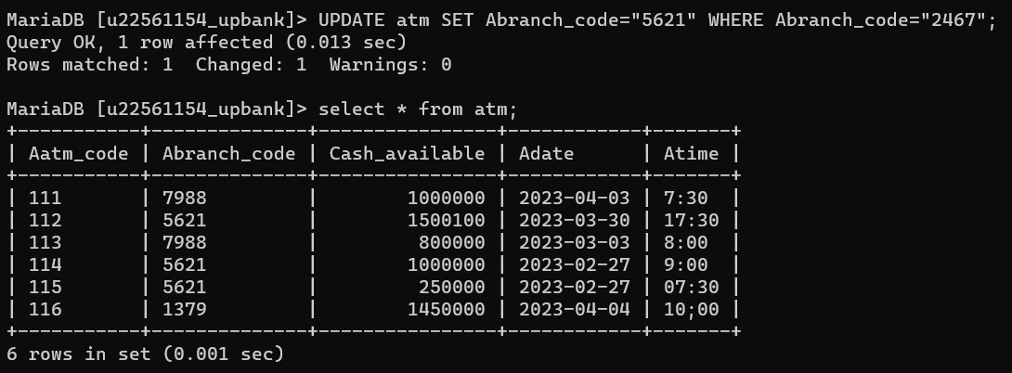

5.5) SELECT a.Aunique_num, a.account_type, COUNT(t1. unique_num) + COUNT(t2.Sunique_num) + COUNT(t3.Funique_num) AS num_transactions

FROM account a

LEFT JOIN cheque t1 ON a.Aunique_num = t1.unique_num

LEFT JOIN savings t2 ON a.Aunique_num = t2.Sunique_num

LEFT JOIN forex t3 ON a.Aunique_num = t3.Funique_num

GROUP BY a.Aunique_num;

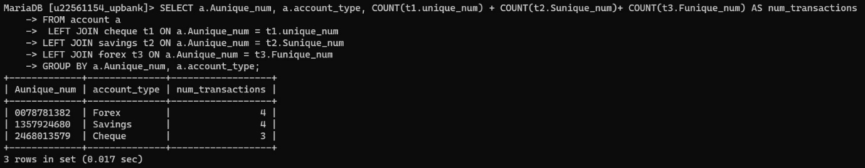

**TASK 6:**

6.1) \select_{Aatm_code LIKE 'ABC123%'} (atm);

6.2) \project_{Catm_code, cit_contact} (cit_Contract \join (\select_{ Bbranch_code =7988} Branch) cit)

6.3) \project_{ Fname, Ccontact_detail } (\select_{ (count(savings) + count(cheque) + count(forex) > 24 and transaction_date >= '2022-06-04')) ((client \join account) \join savings \join cheque \join forex))